YOLO KIOSK (LOCKTASK MODE)

Enabling admin is only possible on devices which don’t have any users added. So before we install app we have to wipe device/factory reset if any Google accounts have been added. Steps:

1) Wipe/Factory reset device.
2) Do not add Google account on the first start, just skip it.
3) Install our application with Android Studio.
4) Set device admin:
adb shell dpm set-device-owner android.com.YOLOHealthATM.YOLOKiosk/.DeviceAdminReceiver
On successfull implementation you will see this result:
To check manually on device: Settings → Security → Device administrators

UNLOCK KIOSK MODE
We had specified the attribute in our AndroidManifest.xml so it will be possible to uninstall the app or remove admin with:

adb shell dpm remove-active-admin android.com.YOLOHealthATM.YOLOKiosk/.DeviceAdminReceiver

On successfull removal of admin you will see this result:
But on the production device, this attribute should be deleted so that the app will become a non-test admin. From that point, it will not be possible to remove it or uninstall the application without wipe/Factory reset. It’s also important to remember that if you build an app from the Android Studio, it will be signed with a default key from Android and the application will become a non-test admin. After some time, if you would like to add some new features you will realize that it’s not possible to install a new version. Thankfully, updates can be done when the app is signed with the same key when version code is equal or greater with installed app.

For more info, follow below link:
https://snow.dog/blog/kiosk-mode-android

Proxy Server:
For setting proxy connection, the Java files are in two packages named ‘thread’ and ‘util’.
Further :
1) In MainActivity class: private StartProxyThread proxyThread;
2) In onCreate method: proxyThread = new StartProxyThread();
3) After creating WiFi-Direct group, call this in onSuccess() method: proxyThread.start();
After calling this, serverSocket gets proxy port 8282 in StartProxyThread class and it runs ProxyConnectionThread class which establishes connection and manages streams from both side.

Connect Kit to Tab’s WiFi-Direct.
To configure proxy settings on Kit use following
IP address : 192.168.49.1
Port : 8282

WiFi-Direct:
Create Group:
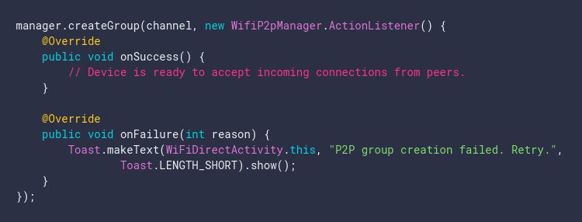
When Kit gets connected to WiFi-Direct, it triggers WIFI_P2P_CONNECTION_CHANGED_ACTION
flag and it will search for IP address of kit in ARP table using readAddress() method.
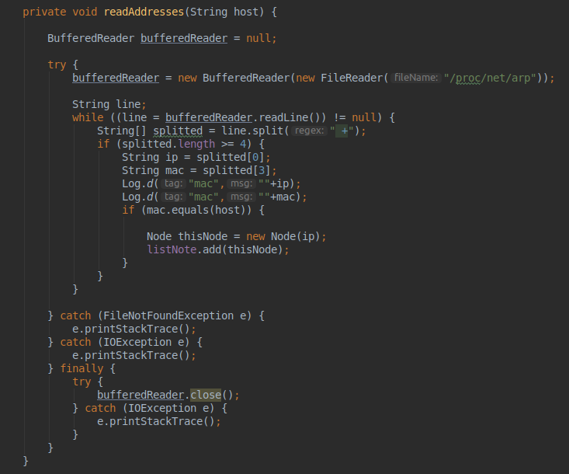

WiFi:
On click of WiFi button, a list of available WiFi networks appear in pop-up.
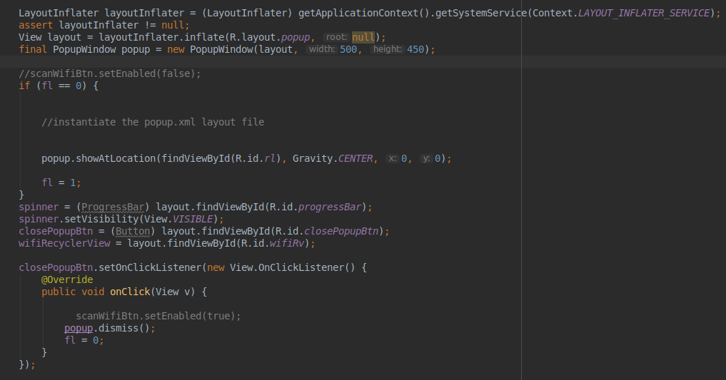
Searching takes place and we use list of ScanResult to get available network.
Connect to desired network by looking at strength of the network.
Setting up adapter for RecyclerView and a dialog pop-ups on click of WiFi network.
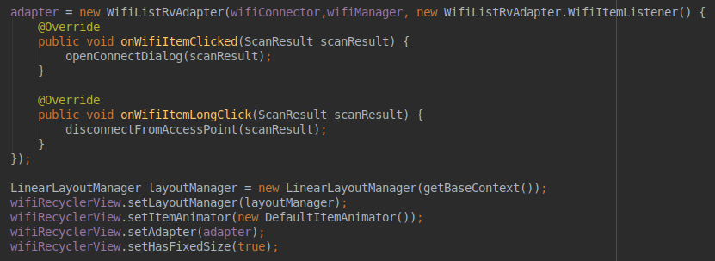

Wifi gets configured using this.
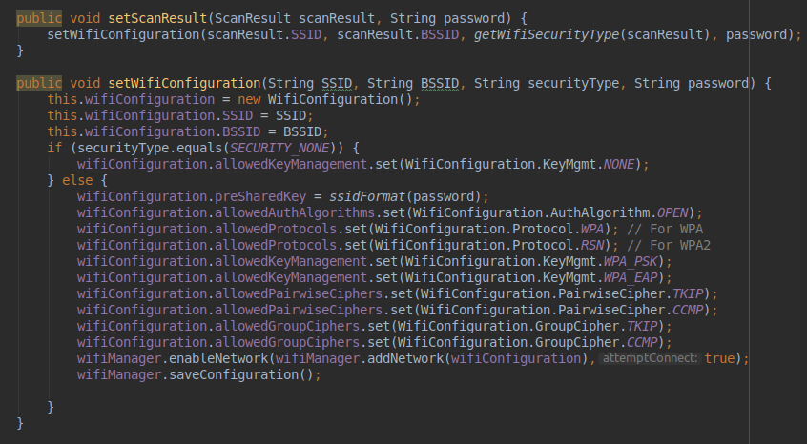
Forget network by long press on WiFi network.
